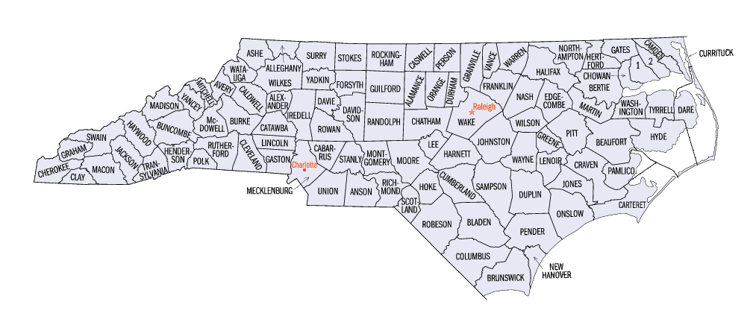NORTH CAROLINA
A. PHILIP RANDOLPH INSTITUTE, INC.
P.O. Box 10428
Raleigh, North Carolina 27605
(919) 833-6671

Advertiser’s Name______________________________
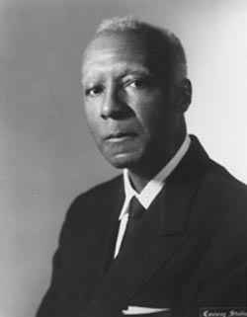
Address _____________________________________
_____________________________________
Telephone # __________________________________

DEADLINE: March 31, 2017 (PLEASE SEND A CAMERA-READY AD OR EMAIL IT TO sgrimes@ncapri.org)

Diamond Sponsor $2000.00 Contribution (includes 14 tickets, full page ad, recognition and special seating)

Platinum Sponsor $1500.00 Contribution (includes 6 tickets, full page ad, recognition and special seating)

Gold Sponsor $700.00 Contribution (includes 2 tickets, half page ad, recognition and special seating)

Silver Sponsor $500.00 Contribution (includes 1 tickets, quarter page ad and recognition)

FULL PAGE $150.00

HALF PAGE $ 75.00

QUARTER-PAGE $50.00

BUSINESS CARD $25.00

PATRONS PAGE $1.00 PER NAME

BANQUET TICKET $60.00 EACH

PLEASE COMPLETE THIS FORM AND MAIL ALONG WITH YOUR PAYMENT FOR TICKETS, JOURNAL AD, AND SPONSORSHIPS TO THE ADDRESS BELOW.

For questions regarding ads, please contact:

Ms. Shavon Grimes @ (919) 833-6671

Return responses to: Ms. Dianne Jackson
North Carolina A. Phillip Randolph Institute, Inc.
P. O. Box 10428
Raleigh, North Carolina 27605

Make Checks Payable to: NCAPRI

